Neil Doherty

Professor Foss

CS 255

February 21, 2021

# CS 255 System Design Document Template

## UML Diagrams

### UML Use Case Diagram

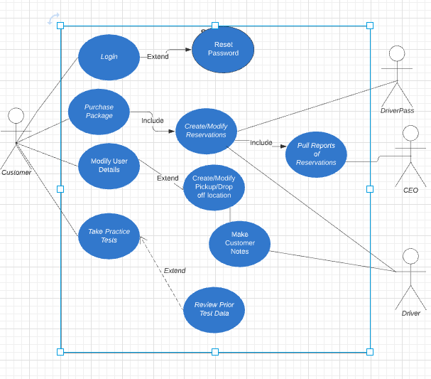

### UML Activity Diagrams

*Create Online Reservation Diagram:*

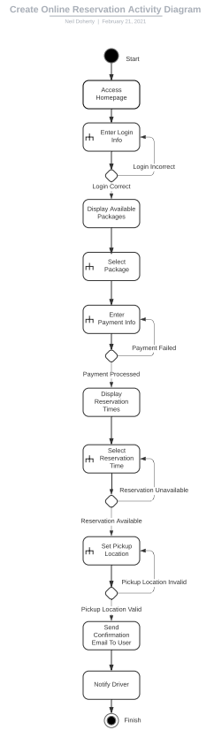

*Practice Test Activity Diagram:*

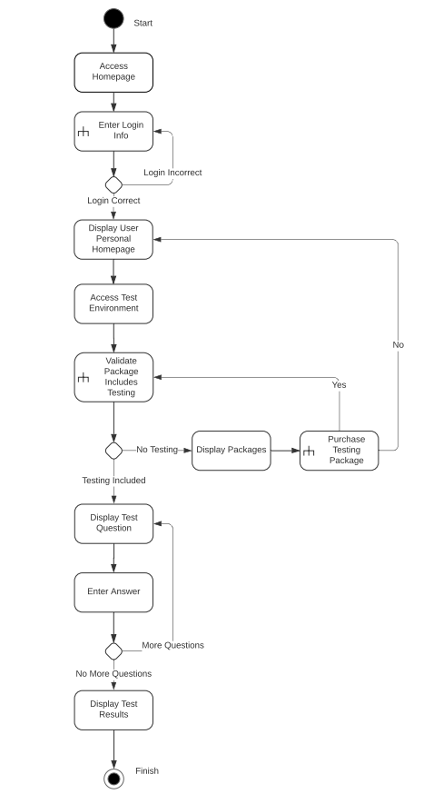

### UML Sequence Diagram

*Create Online Reservation Sequence Diagram:*

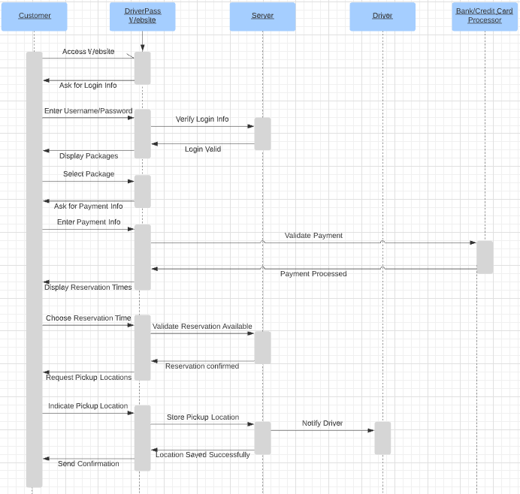

### UML Class Diagram

*DriverPass Class Diagram:*

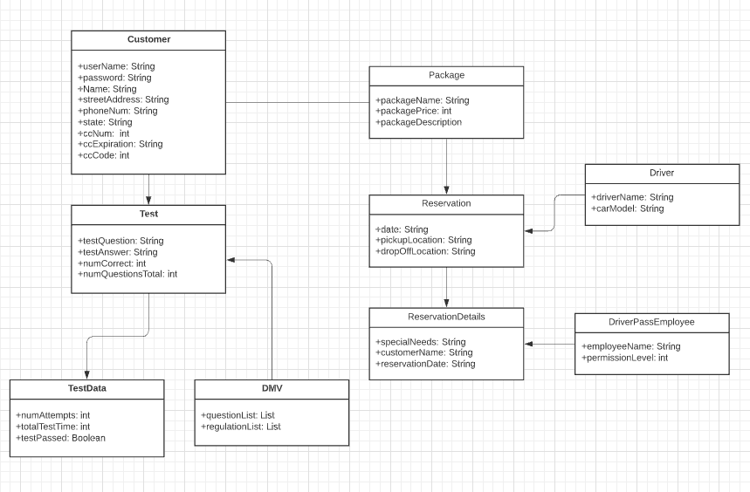

## Technical Requirements

The technical requirements for the DriverPass system involve a few different components. First, the system will require a cloud-based server to store data. The server will contain information related to user accounts, the types of packages available and their prices, the reservation data, and data for the practice tests. The server should be secured and personal data for users should be encrypted. The second critical aspect of the system is reliable internet access. This is required for the server to be accessed, manage reservations and user accounts, and provide drivers with the information they need to complete reservations. The final critical component to make the system function is access to a computer or piece of hardware that can access a web browser. While users can purchase packages and set up appointments by phone, to utilize the full functionality of DriverPass, a computer with a web browser will be required.

In addition to these core components, there are other lesser requirements that will be needed to ensure the system functions optimally. For site security, Secure Socket Layer certificates and reCAPTCHA software will be needed. The system needs to utilize User Account Control to make sure that users are only accessing information they are entitled to. Finally, for reporting data, an aggregation software, such as Qlikview, should be used to see reports from the server regarding reservation information. With these technical requirements, the system will function as intended.